Annex __. Instructions for Obtaining DUNS Number

INSTRUCTIONS FOR OBTAINING A DUNS NUMBER
All applicants must be registered for the Data Universal Numbering System (DUNS). Information on how to obtain the DUNS number can be found at: https://fedgov.dnb.com/webform/index.jsp.
--------------------------------------------------------------------------------------------------------------------------
THE PROCESS FOR OBTAINING A DUNS NUMBER IS OUTLINED BELOW:

- Log on to the D&B (Dun & Bradstreet) DUNS registration website to begin the process of obtaining a DUNS number free of charge: http://fedgov.dnb.com/webform/index.jsp

Please note there is a bar on the left for Frequently Asked Questions as well as emails and telephone numbers for persons at Dun & Bradstreet for you to contact if you have any questions or difficulties completing the application on-line. D+ is not authorized to complete the application on your organization’s behalf; the required data must be entered by an authorized official of your organization.

- Select the country where your organization/entity is physically located.

- You will first be asked to search the existing DUNS database to see whether a DUNS number already exists for your organization/entity. Subcontractors/grantees who already have a DUNS number may verify/update their DUNS records.

- Organizations/entities who do not already have a DUNS number will see the screen below. In that case, request a new DUNS Number, by selecting the “Request a New D-U-N-S Number” button.
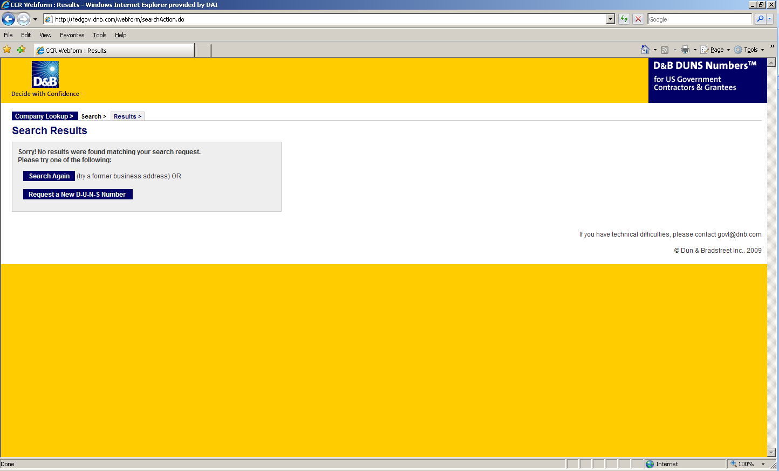

- Enter the information regarding your organization/entity listed on the next three screens. (See screen shots below.) Make sure you have the following information available (in English) prior to beginning the process of entering this section in order to ensure successful registration.

- Legal Business Name (commas are allowed, periods are not allowed)
- Address
- Phone
- Name of Owner/Executive
- Total Number of Employees
- Annual Sales or Revenue (US Dollar equivalent)
- Description of Operations

- Note that some fields are Optional, however all other fields must be completed to proceed further with the application process. For example, all applicants must complete the Organization Information sections. The Company Name and Physical Address fields are self-populated based on information previously entered during the initial DUNS search. The question marks to the left of the field provide additional information when you click on them.
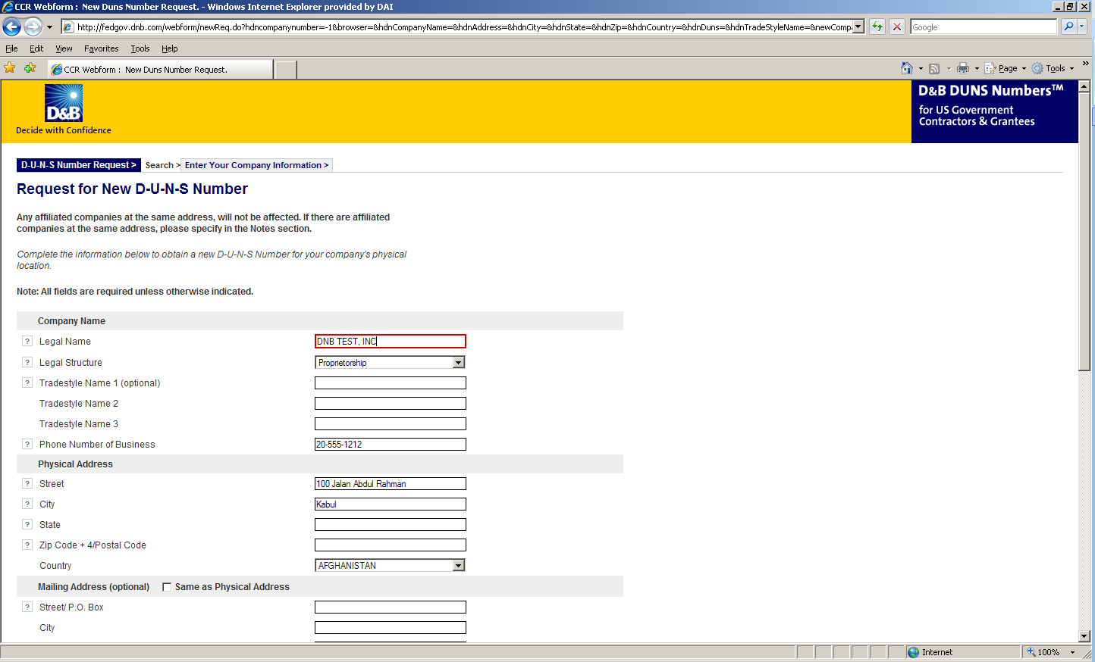

- Select the legal structure of your organization from the drop-down menu. To assist you in selecting the appropriate structure that best represents your organization/entity, a brief description of the various types follows:

- Corporation – A firm that meets certain legal requirements to be chartered by the state/province in which it is headquartered by the filing of articles of incorporation. A corporation is considered by law to be an entity separate and distinct from its owners. It can be taxed; it can be sued; it can enter into contractual agreements.
- Government - central, province/state, district, municipal and other U.S. or local government entities. Includes universities, schools and vocational centers owned and operated by the government.
- Limited Liability Company (LLC) - This is a type of business ownership combining several features of corporation and partnership structures. It is designed to provide the limited liability features of a corporation and the tax efficiencies and operational flexibility of a partnership. Its owners have limited personal liability for the LLC’s debts and obligations, similar to the status of shareholders in a corporation. If your firm is an LLC, this will be noted on the organization’s registration and licensing documents.
- Non-profit - An entity which exists for charitable reasons and is not conducted or maintained for the purpose of making a profit. Any money earned must be retained by the organization, and used for its own expenses, operations, and programs. Most organizations which are registered in the host country as a non-governmental organization (NGO) rather than as a commercial business are anon-profit entities.
Community based organizations, trade associations, community development councils, and similar entities which are not organized as a profit-making, should select this status, even if your organization is not registered formally in country as an NGO.
- Partnership- a legal form of operation in which two or more individuals carry on a continuing business for profit as co-owners. The profits and losses are shared proportionally.
- Proprietorship-These firms are owned by one person, usually the individual who has day-to-day responsibility for running the business. Sole proprietors own all the assets of the business and the profits generated by it.

- One of the most important fields that must be filled in is the Primary SIC code field. (See screen shot below) The Primary Standard Industrial Code classifies the business’ most relevant industry and function.
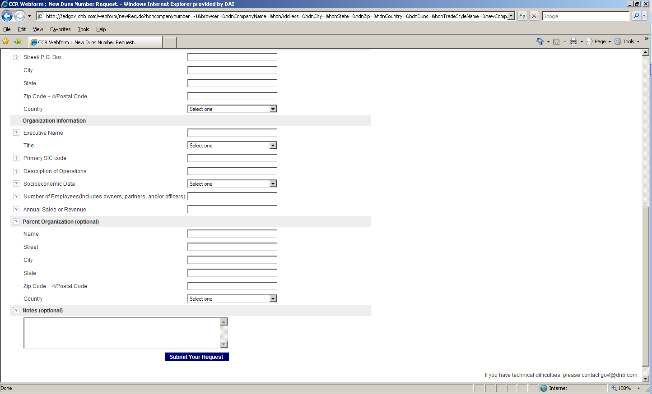
- If you are unsure of which SIC Code your organization’s core business falls under, please refer to the following website: http://www.osha.gov/oshstats/sicser.html
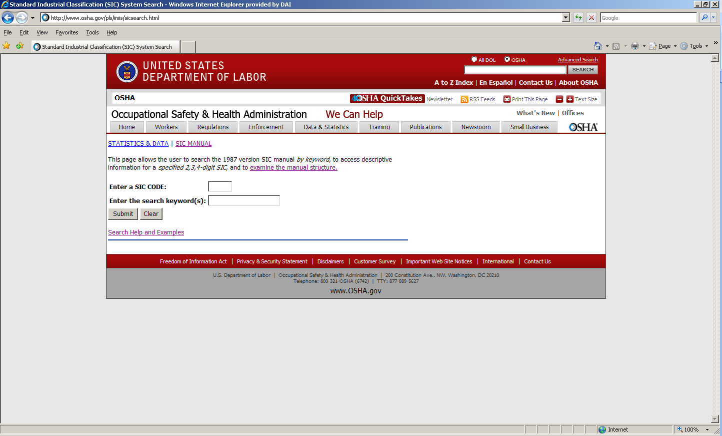
You will need to enter certain keywords to bring up the potential SIC Codes. In the case above, “Research” was entered as the keyword, and resulted in the following:
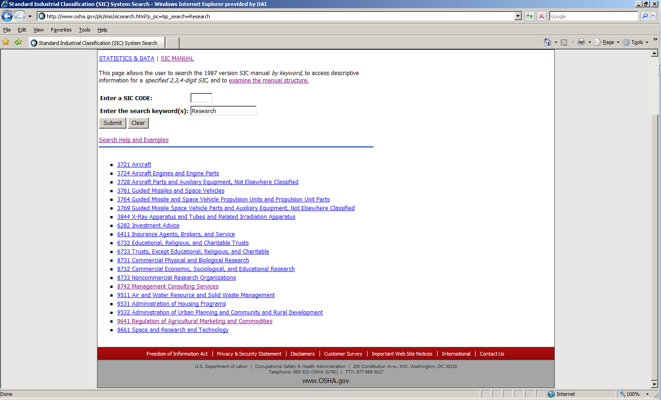
PLEASE NOTE: Many of the D+ subcontractors and grantees fall under one of the following SIC codes:
8742 Management Consulting Services
1542 General Contractors-Nonresidential Buildings, Other than Industrial Buildings and Warehouses or one of the codes within:
Industry Group 357: Computer And Office Equipment
Industry Group 355: Special Industry Machinery, Except Metalworking
Industry Group 356: General Industrial Machinery And Equipment
Industry Group 359: Miscellaneous Industrial And Commercial

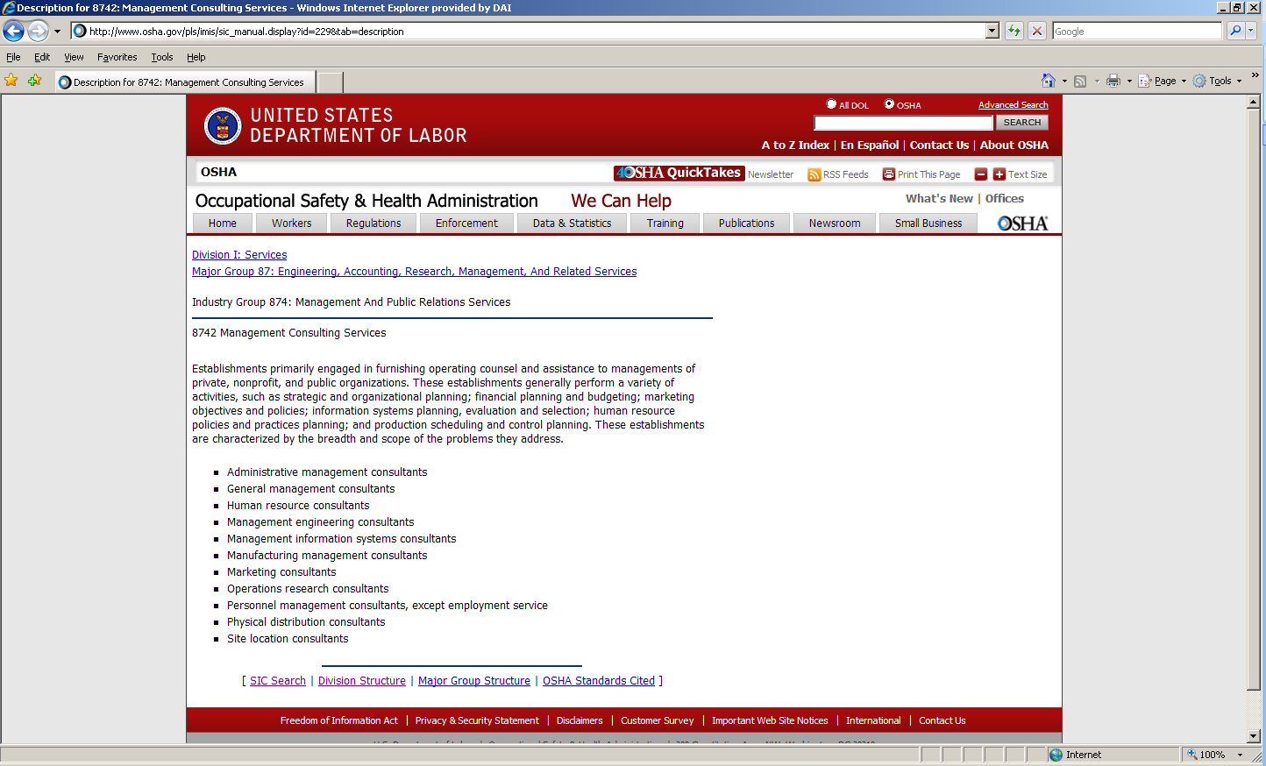

- Description of Operations- Enter a brief description of the primary services you provide the example below, “agricultural technical assistance” was chosen as the primary function of the business.
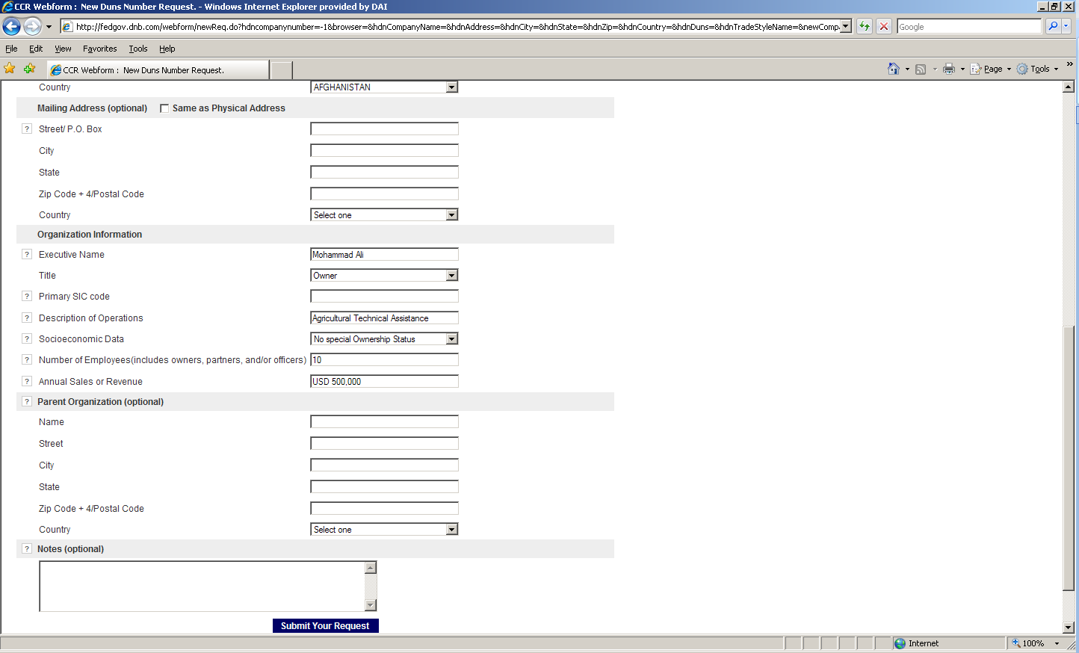
- The Annual Sales or Revenue figure should be provided in USD (US Dollar) equivalent.
- Once all of the fields have been completed, click on “Submit Your Request” to be taken to the Verification page.
- Note: Representative (Principal, Owner or Officer) needs to verify and provide affirmation regarding the accuracy of the data under criminal or civil penalties as per Title 18, Section 1001 of the US Criminal Code.
- Once “Yes, continue” button is clicked, the registration application is sent to D&B, and a DUNS number should be available within 24-48 hours. DUNS database can be checked in 24-48 hours by entering the Business Information in the Search window – which should now display a valid result with the new DUNS number for the entity.
